VENANGO TECHNOLOGY CENTER
JOINT COMMITTEE
1 Vo-Tech Drive
Oil City, Pennsylvania 16301

MINUTES

October 3, 2022

The regular meeting of the Venango Technology Center Joint Committee was held this evening in the Cafeteria of the Venango Technology Center, 1 Vo-Tech Drive, Oil City, PA 16301. Mr. Carson called the meeting to order at seven o’clock (7:00) p.m.

Mr. Carson asked the members to pause for a moment of silence.

Mr. Carson asked the members to stand for the pledge of allegiance.

Roll Call: Present: Ben Carbaugh, Troy Johnston, Shari Neely, Lynn Cressman (zoom), Stephen
Kelley, Jeff Thomas (zoom), Don Judy (zoom), Todd Carson

Absent: Mark Marterella, Andy Boland,

Also Present: Mr. Mario Fontanazza, Mr. Kevin Briggs

Mr. Carson stated the Joint Committee members had received copies of the Minutes of the September 6, 2022 meeting in the mail. He asked if there were any additions, corrections or deletions.

Mrs. Neely, seconded by Mr. Kelley, moved to approve the Minutes of the September 6, 2022 meeting as submitted.

Roll Call: Ayes: Ben Carbaugh, Troy Johnston, Shari Neely, Lynn Cressman, Stephen Kelley, Jeff
Thomas, Don Judy, Todd Carson

Nayes: None, motion carried.

The Treasurer and Secretary’s Report and the Special Account report for 10/3/2022 were submitted for information.

Mr. Carbaugh, seconded by Mrs. Neely, moved to accept the Treasurer and Secretary’s Report and the Special Account report for 10/3/2022 were approved as is.

The motion was unanimously approved.

A list of bills from 9/7/22 – 10/3 /22 in the amount of $928,236.79 were presented for approval.

Mr. Carbaugh, seconded by Mr. Kelley, moved to approve the list of bills as presented.

Roll Call: Ayes: Ben Carbaugh, Troy Johnston, Shari Neely, Lynn Cressman, Stephen Kelley, Jeff
Thomas, Don Judy, Todd Carson

Nayes: None, motion carried.

Under Communications, Mr. Fontanazza discussed the Professional Advisory Committee. He also discussed the Calendar of Events for the month of August and the Monthly Enrollment Report as of 10/3/22 were submitted.

Mr. Carson requested approval of the action items as presented. Item 8. a) i.- xvii. in one motion.

Mrs. Neely, seconded by Mr. Carbaugh, moved to approve action items i.- xvii. in one motion as follows:

- Approve Tuition increase of $300.00 for Practical Nursing for the 2023-2024 school
year to $16,050.00.
- Approve list of equipment for disposal.
- Approve supplemental contract for a passenger van with Muccio Transportation.
- Approve van drivers for Muccio transportation.
- Approve updated OAC list.
- Accept resignation of Casey Eklund Administrative Assistant for Practical Nursing in Warren.
- Approve advertising for an administrative assistant for Warren Practical Nursing.

Roll Call: Ayes: Ben Carbaugh, Troy Johnston, Shari Neely, Lynn Cressman, Stephen Kelley, Jeff
Thomas, Don Judy, Todd Carson

Nayes: None, motion carried.

Mr. Adams discussed the timeline for approval of the 2023-2024 budget.

Mr. Fontanazza reviewed his Issues/Activities for September 2022.

Mr. Carson asked if there was any old business.

None was noted.

Mr. Carson asked if there was any new business.

None was noted.

Upon motion by Mrs. Neely, seconded by Mr. Johnston, the meeting adjourned at eleven minutes past seven (7:11) p.m.

Recorded by
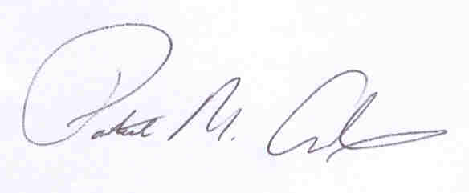
Patrick M. Adams
Secretary, Joint Committee

